**Task 1**

#include <stdio.h>

#include <stdlib.h>

#include<math.h>

int main()

{

float height, weight, bmi;

printf("Enter height in meter\n");

scanf("%f", &height);

printf("Enter weight in kg\n");

scanf("%f", &weight);

bmi = weight / (height * height);

printf("Your Body Mass Index(BMI) is %f\n", bmi);

if(bmi<16){

printf("Dangerously underweight");

return 0;

}

else if (bmi<19){

printf("Underweight");

return 0;

}

else if (bmi<24){

printf("Normal weight");

return 0;

}

else if (bmi<29){

printf("over weight");

return 0;

}

printf("seriously overweight");

}

Output

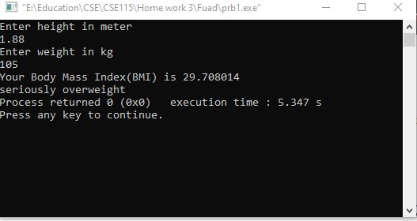

**Task 2**

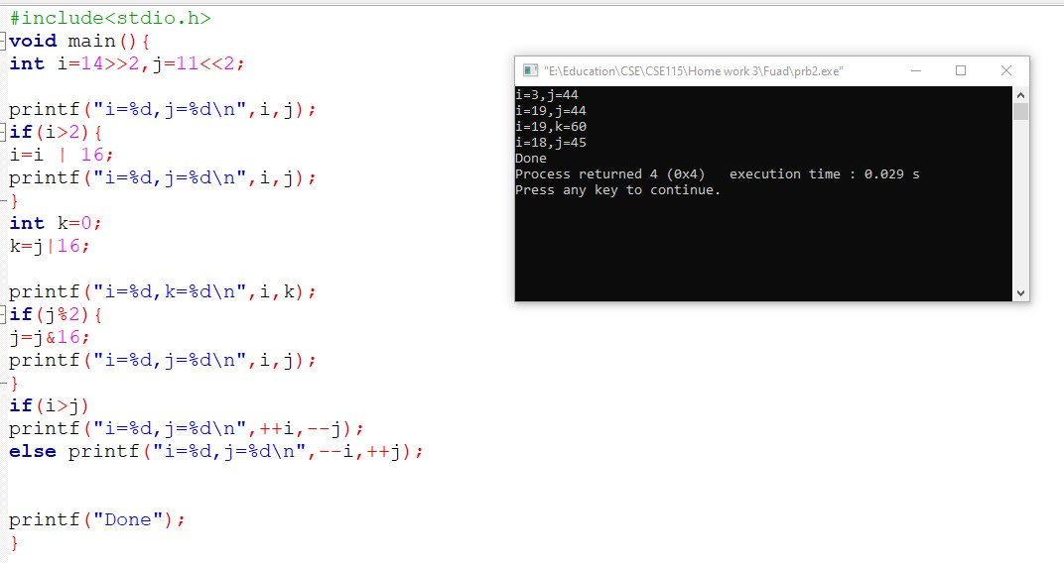

**Task 3**

#include <stdio.h>

int main() {

double n1, n2, n3;

printf("Enter three numbers: ");

scanf("%lf %lf %lf", &n1, &n2, &n3);

if (n1 >= n2) {

if (n1 >= n3)

printf("%.2lf is the largest number.", n1);

else

printf("%.2lf is the largest number.", n3);

} else {

if (n2 >= n3)

printf("%.2lf is the largest number.", n2);

else

printf("%.2lf is the largest number.", n3);

}

return 0;

}

Output

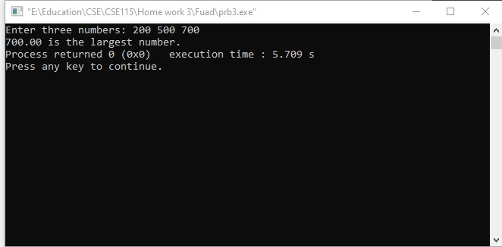

**Task 4**

#include<stdio.h>

#include<conio.h>

int main()

{

float noOfCall, tempNoOfCall, charge;

printf("Enter the number of minutes talked in phone: ");

scanf("%f", &noOfCall);

printf("\n");

float bill=0;

if(noOfCall>=95)

{

charge = (5 * 0.3)+(30 * 0.5)+(60 * 0.75 )+((noOfCall-5-30-60) * 1) ;

noOfCall=0;

}

else if(noOfCall>=35)

{

charge = (5 * 0.3)+(30 * 0.5)+((noOfCall-5-30) * 0.75) ;

noOfCall=0;

}

else if(noOfCall>=5)

{

charge = (5 * 0.3)+((noOfCall-5)*0.5);

noOfCall=0;

}

else if(noOfCall>=0)

{

charge = (noOfCall * 0.3);

noOfCall=0;

}

charge = 1.15*charge;

printf("The charge you have to paid = %f taka", charge);

getch();

return 0;

}

Output

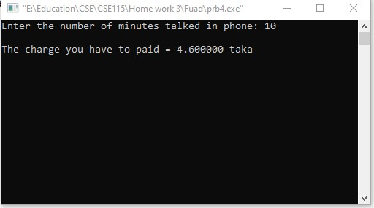

**Task 5**

#include <stdio.h>

int main() {

double num;

printf("Enter a number: ");

scanf("%lf", &num);

if (num <= 0.0) {

if (num == 0.0)

printf("You entered 0.");

else

printf("You entered a negative number.");

} else

printf("You entered a positive number.");

return 0;

}

Output

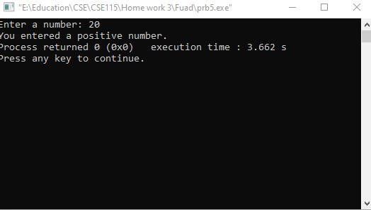

**Task 6**

#include<stdio.h>

int main()

{ char n; //declare a variable

printf("Enter a your input : ");

scanf("%c",&n);

if(n>='0' && n<='9') //check for digit

{

printf("Digit.");

}

else if(n>='A' && n<='Z') //check for uppercase

{

printf("Uppercase alphabet .");

}

else if(n>='a' && n<='z') //check for lowercase

{

printf("Lowercase alphabet.");

}

return 0;

}

Output

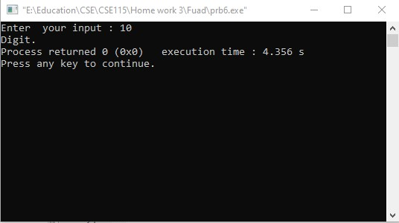

**Task 7**

**Part a:**

#include <stdio.h>

int main() {

char op;

int num1, num2;

printf("Enter an operator (+, -, *, /): ");

scanf("%c", &op);

printf("Enter two operands: ");

scanf("%d %d", &num1, &num2);

switch (op) {

case '+':

printf("%d + %d = %d", num1, num2, num1 + num2);

break;

case '-':

printf("%d - %d = %d", num1, num2, num1 - num2);

break;

case '*':

printf("%d * %d = %d", num1, num2, num1 * num2);

break;

case '/':

printf("%d / %d = %d", num1, num2, num1 / num2);

break;

// operator doesn't match any case constant

default:

printf("Error! operator is not correct");

}

return 0;

}

Output:

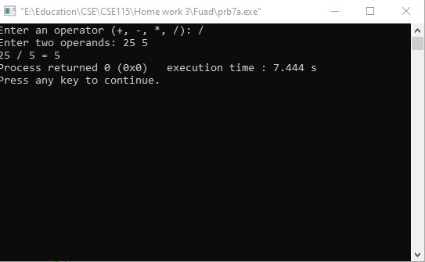

**Part B**

#include<stdio.h>

void main()

{

int num1, num2, cal; //decleration of integer variables

char ope; //decleration of character variables

printf("Enter First Number : ");

scanf("%d", &num1); //Getting the first value from user

printf("Enter Second Number : ");

scanf("%d", &num2); //Getting the second value from user

printf("Choose Any Operator: + | - | / | * \n");

scanf(" %c", &ope); // getting the operator for operation from user

// Applying if-else condition to check conditions

if(ope == '+')

{

cal= num1 + num2;

printf("Addition of two numbers is: %d",cal);

}

else if(ope == '-')

{

cal= num1 - num2;

printf("Subtraction of two numbers is: %d",cal);

}

else if(ope == '/')

{

cal= num1 / num2;

printf("Division of two numbers is: %d",cal);

}

else if(ope == '*' )

{

cal= num1 * num2;

printf("Multiplication of two numbers is: %d",cal);

}

else

{

printf("Invalid Input");

}

}

Output:

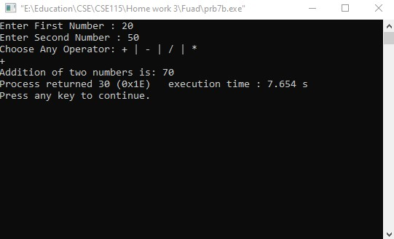

**Task 8**

#include <stdio.h>

int main() {

char month_number;

printf("Enter month number (Between 1(JANUARY) and 12(DECEMBER)): ");

scanf("%c", &month_number);

switch (month_number)

{

case '1':

printf("Number of days in January = 31");

break;

case '2':

printf("Number of days in February = 28");

break;

case '3':

printf("Number of days in March= 31");

break;

case '4':

printf("Number of days in April = 30");

break;

case '5':

printf("Number of days in May = 31");

break;

case '6':

printf("Number of days in June = 30");

break;

case '7':

printf("Number of days in July = 31");

break;

case '8':

printf("Number of days in August = 31");

break;

case '9':

printf("Number of days in September = 30");

break;

case '10':

printf("Number of days in October = 31");

break;

case '11':

printf("Number of days in November = 30");

break;

case '12':

printf("Number of days in December = 31");

break;

// operator doesn't match any case constant

default:

printf("Error! NO such Month Exists");

}

return 0;

}

Output:

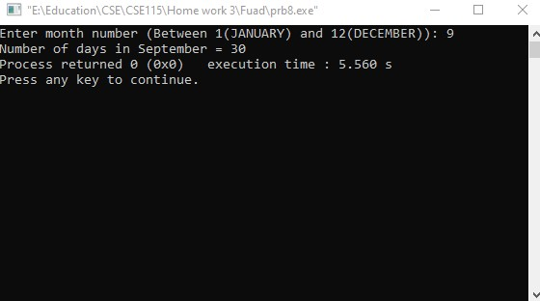

**Task 9**

#include <stdio.h>

int main()

{

int number;

printf("Enter the number: ");

scanf("%d", &number);

if(number%2==0)

printf("Number is Even");

else

printf("Number is Odd");

return 0;

}

Output

